Base Face

Definition
# Source: AI Source: Provided by: [Data Path: Persons Table -> ID Column: 1, Name_En Column: Motasem Essam] -> From: [ChatGPT] on [7/25/2026]
A base face is a face of a three-dimensional solid that serves as its base or principal supporting face. Depending on the solid, it may be a polygon or another plane region, and a solid may have one base or two parallel, congruent bases.
Base faces are especially important in prisms, pyramids, cylinders, and cones because they help determine the solid's shape, height, volume, and surface area.
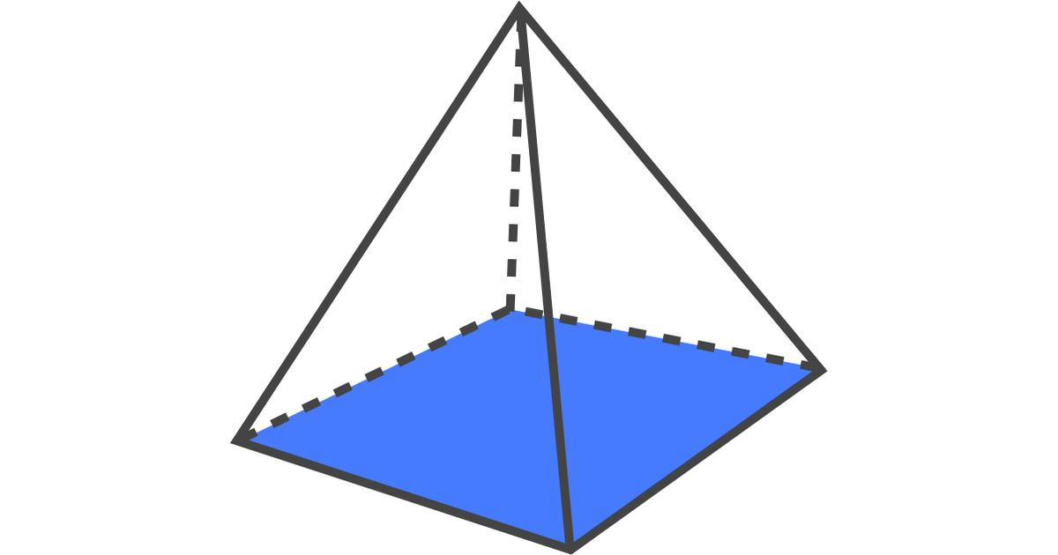
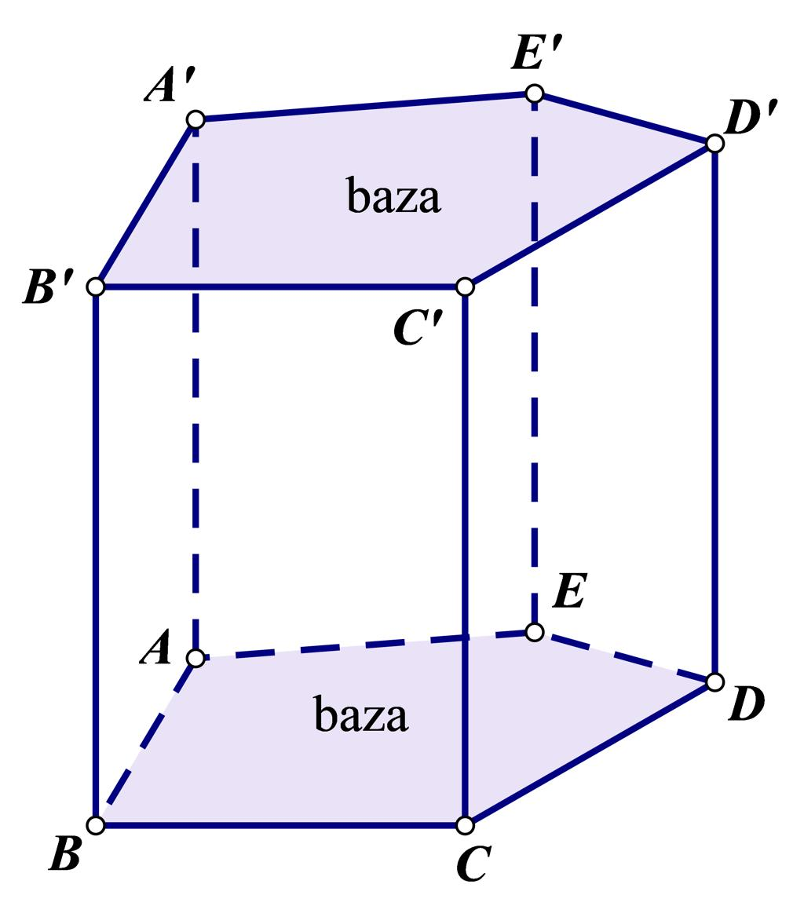
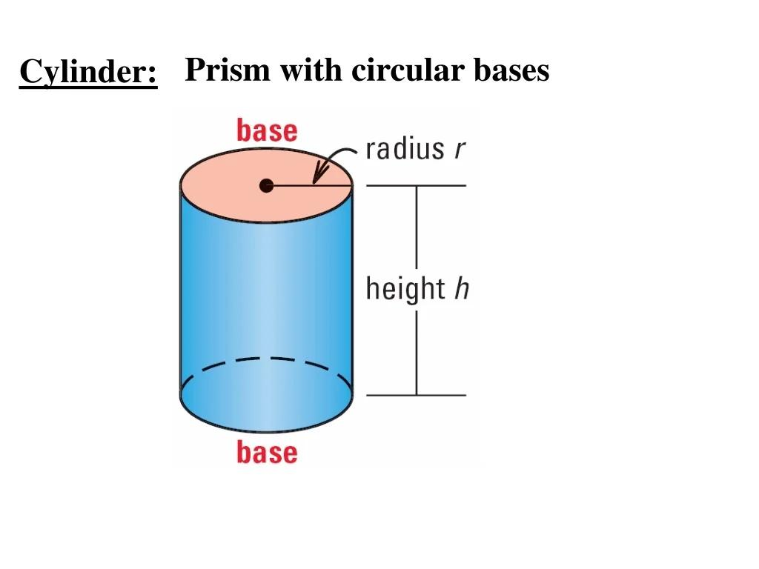

Simple Definition
# Source: AI Source: Provided by: [Data Path: Persons Table -> ID Column: 1, Name_En Column: Motasem Essam] -> From: [ChatGPT] on [7/25/2026]
A base face is the face chosen as the base of a solid.
Examples:
- The square bottom face of a square pyramid.
- Either of the two parallel pentagonal faces of a pentagonal prism.
- The circular bottom face of a cylinder.
- The circular base of a cone.
A base face is not necessarily the face that physically touches the ground. The solid can be rotated, and the base used in a mathematical description may depend on its orientation or how it is defined.

Classification Tree
# Source: AI Source: Provided by: [Data Path: Persons Table -> ID Column: 1, Name_En Column: Motasem Essam] -> From: [ChatGPT] on [7/25/2026]
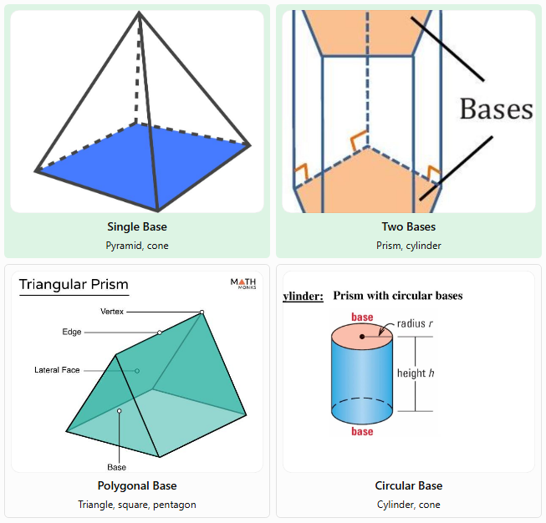
Single Base
Pyramid, cone
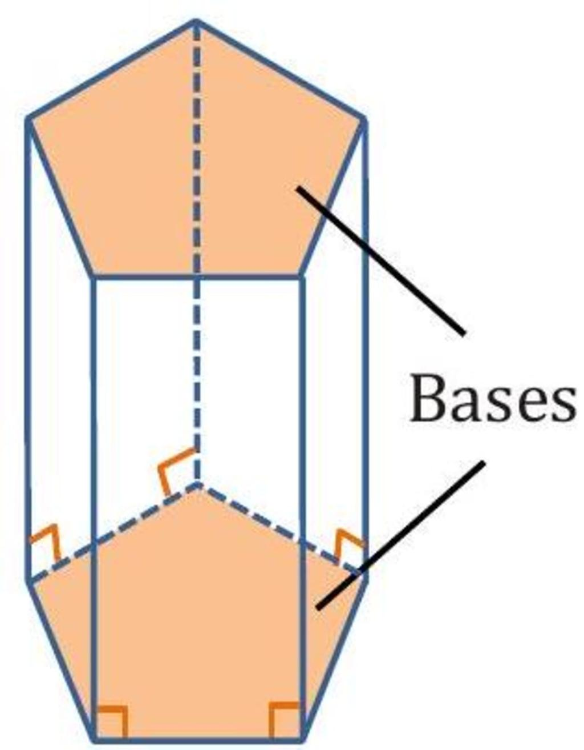
Two Bases
Prism, cylinder
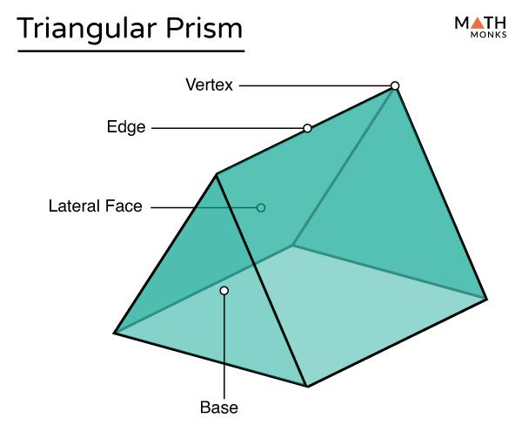
Polygonal Base
Triangle, square, pentagon
Circular Base
Cylinder, cone
The classification above distinguishes solids by the number and shape of their bases. A circular base is a flat circular region, not a polygonal face.

Key Characteristics of a Base Face
# Source: AI Source: Provided by: [Data Path: Persons Table -> ID Column: 1, Name_En Column: Motasem Essam] -> From: [ChatGPT] on [7/25/2026]
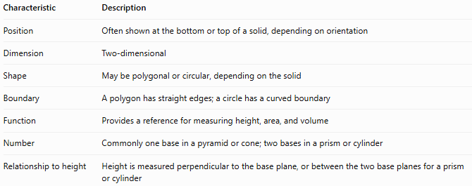
Characteristic | Description
Position | Often shown at the bottom or top of a solid, depending on orientation
Dimension | Two-dimensional
Shape | May be polygonal or circular, depending on the solid
Boundary | A polygon has straight edges; a circle has a curved boundary
Function | Provides a reference for measuring height, area, and volume
Number | Commonly one base in a pyramid or cone; two bases in a prism or cylinder
Relationship to height | Height is measured perpendicular to the base plane, or between the two base planes for a prism or cylinder

Geometric Representation
# Source: AI Source: Provided by: [Data Path: Persons Table -> ID Column: 1, Name_En Column: Motasem Essam] -> From: [ChatGPT] on [7/25/2026]
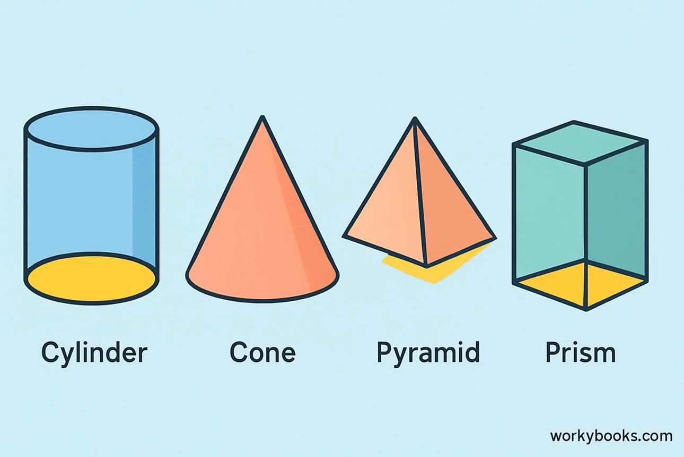

A. Base face of a pyramid
# Source: AI Source: Provided by: [Data Path: Persons Table -> ID Column: 1, Name_En Column: Motasem Essam] -> From: [ChatGPT] on [7/25/2026]
A pyramid has one polygonal base. Its lateral faces are triangles that meet at a common apex.
Examples:
- A triangular pyramid has a triangular base.
- A square pyramid has a square base.
- A pentagonal pyramid has a pentagonal base.

B. Base faces of a prism
# Source: AI Source: Provided by: [Data Path: Persons Table -> ID Column: 1, Name_En Column: Motasem Essam] -> From: [ChatGPT] on [7/25/2026]
A prism has two parallel, congruent polygonal bases. The other faces connect corresponding edges of these bases.
Examples:
- A triangular prism has two triangular bases.
- A rectangular prism has two opposite rectangular bases, although other faces may also be rectangles.
- A hexagonal prism has two hexagonal bases.

C. Base face of a cylinder
# Source: AI Source: Provided by: [Data Path: Persons Table -> ID Column: 1, Name_En Column: Motasem Essam] -> From: [ChatGPT] on [7/25/2026]
A cylinder has two parallel, congruent circular bases connected by a curved lateral surface.

D. Base face of a cone
# Source: AI Source: Provided by: [Data Path: Persons Table -> ID Column: 1, Name_En Column: Motasem Essam] -> From: [ChatGPT] on [7/25/2026]
A cone has one circular base and one curved lateral surface that narrows toward the apex.

6. Mathematical Representations and Formulas
# Source: AI Source: Provided by: [Data Path: Persons Table -> ID Column: 1, Name_En Column: Motasem Essam] -> From: [ChatGPT] on [7/25/2026]
The formulas below use the area of the base, $B$, and the perpendicular height, $h$.

A. Volume
# Source: AI Source: Provided by: [Data Path: Persons Table -> ID Column: 1, Name_En Column: Motasem Essam] -> From: [ChatGPT] on [7/25/2026]
For a prism or cylinder:
$$V=Bh$$
For a pyramid or cone:
$$V=\frac{13}{B}h$$
Here, $B$ is the area of one base and $h$ is the perpendicular height.

B. Common base-area formulas
# Source: AI Source: Provided by: [Data Path: Persons Table -> ID Column: 1, Name_En Column: Motasem Essam] -> From: [ChatGPT] on [7/25/2026]
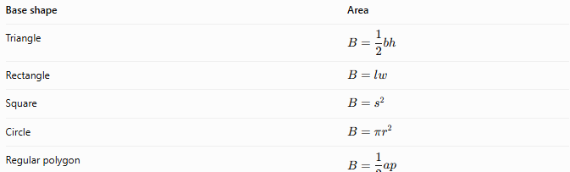
Base shape | Area
Triangle | $$B=\frac{12}{b}h$$
Rectangle | $$B=lw$$
Square | $$B=s^{2}$$
Circle | $$B=πr^{2}$$
Regular polygon | \$B=\frac{12}{a}p$
In these formulas, $b$ is the triangle's base length, $h$ its perpendicular height, $l$ and $w$ are rectangle dimensions, $s$ is the square's side length, $r$ is the circle's radius, $a$ is the apothem of a regular polygon, and $p$ is its perimeter. The triangle's height in the area formula is distinct from the height of the three-dimensional solid.

C. Surface area
# Source: AI Source: Provided by: [Data Path: Persons Table -> ID Column: 1, Name_En Column: Motasem Essam] -> From: [ChatGPT] on [7/25/2026]
For a right prism:
$$SA=2B+ph$$
For a right circular cylinder:
$$SA=2πr^{2}+2πrh$$
For a right pyramid:
$$SA=B+\text{lateral area}$$
For a right circular cone:
$$SA=πr^{2}+πrl$$
Here, $p$ is the perimeter of the prism's base and $l$ is the slant height of the cone. These formulas include all exposed surfaces for the indicated solids.

Worked Examples
# Source: AI Source: Provided by: [Data Path: Persons Table -> ID Column: 1, Name_En Column: Motasem Essam] -> From: [ChatGPT] on [7/25/2026]
Example 1: Finding the base area of a square pyramid
A square pyramid has a base side length of $6\text{ cm}$ and a perpendicular height of $10\text{ cm}$. Find the base area and volume.
Step 1: Calculate the base area.
$$B=s^{2}=6^{2}=36{\text{ cm}}^{2}$$
Step 2: Calculate the volume.
$$V=\frac{13}{B}h$$
$$V=\frac{13}{\left(36\right)}\left(10\right)=120{\text{ cm}}^{3}$$
Answer: The base area is $36{\text{ cm}}^{2}$, and the volume is $120{\text{ cm}}^{3}$.
Example 2: Finding the volume of a triangular prism
A triangular prism has a triangular base with a base length of $8\text{ cm}$ and a perpendicular triangle height of $5\text{ cm}$. The prism's length is $12\text{ cm}$. Find its volume.
Step 1: Calculate the triangular base area.
$$B=\frac{12}{\left(8\right)}\left(5\right)=20{\text{ cm}}^{2}$$
Step 2: Calculate the prism's volume.
$$V=Bh=20\left(12\right)=240{\text{ cm}}^{3}$$
Answer: The volume is $240{\text{ cm}}^{3}$.
Example 3: Finding the base area of a cylinder
A cylinder has a base radius of $4\text{ cm}$ and a height of $9\text{ cm}$. Find the area of one base and the volume.
Step 1: Calculate the circular base area.
$$B=πr^{2}=π{\left(4\right)}^{2}=16π{\text{ cm}}^{2}$$
Step 2: Calculate the volume.
$$V=Bh=16π\left(9\right)=144π{\text{ cm}}^{3}$$
Approximately,
$$V≈452.39{\text{ cm}}^{3}$$
Answer: The base area is $16π{\text{ cm}}^{2}$, and the volume is approximately $452.39{\text{ cm}}^{3}$.

Comparison with Related Concepts
# Source: AI Source: Provided by: [Data Path: Persons Table -> ID Column: 1, Name_En Column: Motasem Essam] -> From: [ChatGPT] on [7/25/2026]
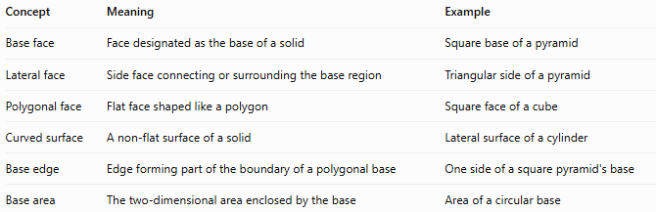
Concept | Meaning | Example
Base face | Face designated as the base of a solid | Square base of a pyramid
Lateral face | Side face connecting or surrounding the base region | Triangular side of a pyramid
Polygonal face | Flat face shaped like a polygon | Square face of a cube
Curved surface | A non-flat surface of a solid | Lateral surface of a cylinder
Base edge | Edge forming part of the boundary of a polygonal base | One side of a square pyramid's base
Base area | The two-dimensional area enclosed by the base | Area of a circular base
Important distinction: A base face is a type of face defined by its role in a solid. A polygonal face is defined by its shape. A base can be polygonal, as in a prism, or circular, as in a cylinder.

Applications of Base Faces
# Source: AI Source: Provided by: [Data Path: Persons Table -> ID Column: 1, Name_En Column: Motasem Essam] -> From: [ChatGPT] on [7/25/2026]
Base faces are useful in:
- Construction: Calculating the footprint and volume of foundations, columns, and structures.
- Packaging: Finding the area needed for the bottom of boxes and containers.
- Engineering: Determining cross-sectional areas and material requirements.
- Architecture: Understanding the dimensions and proportions of pyramidal and prismatic structures.
- Mathematics: Calculating volume, surface area, and perpendicular height.

Key Points
# Source: AI Source: Provided by: [Data Path: Persons Table -> ID Column: 1, Name_En Column: Motasem Essam] -> From: [ChatGPT] on [7/25/2026]
- A base face is a face designated as the base of a solid.
- A pyramid or cone typically has one base; a prism or cylinder has two.
- The base may be polygonal or circular.
- The base area is used in volume formulas.
- Height is measured perpendicular to the base plane, not along a sloping lateral edge.
- The base does not have to be physically at the bottom of the object.

Conclusion
# Source: AI Source: Provided by: [Data Path: Persons Table -> ID Column: 1, Name_En Column: Motasem Essam] -> From: [ChatGPT] on [7/25/2026]
A base face in solid geometry is a fundamental face used to describe a solid and calculate its geometric properties. Identifying the base and determining its area are essential steps when calculating the volume and surface area of prisms, pyramids, cylinders, and cones.

